Public Health Emergency Preparedness and Response

Experiences and lessons learnt from frontline clinicians in the Indo-Pacific region
during the COVID-19 pandemic

Summary for research participants September 2021

Background

The Australasian College for Emergency Medicine (ACEM) is the peak body for emergency medicine (EM) in Australia and New Zealand. ACEM’s Global Emergency Care Committee (GECCo) and Global Emergency Care (GEC) desk are committed to improving the capacity of low- and middle-income countries (LMICs) to deliver safe and effective EC, with a focus on the Indo-Pacific region.

Since the novel coronavirus that causes COVID-19 emerged at the start of 2020, emergency care (EC) clinicians across the world have been on the frontlines of response efforts. Many countries in the Indo-Pacific region have under-developed health systems and were already at limited capacity to provide safe and effective EC before the COVID-19 pandemic. As a rapid response, ACEM’s GECCo organised regular online forums with EC doctors and nurses and health stakeholders across the region to share knowledge, build resources and provide support.

In these forums, participants shared their experiences, concerns and learnings in preparing for COVID-19. They identified local, as well as shared, ethical and clinical challenges. ACEM recognised the need for research to understand these challenges, identify and share learnings and innovative responses from Pacific Island countries (PICs).

In partnership with the Pacific Community (SPC), and with funding from the World Health Organization (WHO) and the ACEM Foundation, ACEM’s GECCo designed a research project to document experiences of EC providers and stakeholders in the Pacific region during the COVID-19 pandemic.

This summary is for our research participants. The ACEM GECCo and SPC research team is incredibly grateful to all participants who generously shared their experiences and learnings.

What we did

In collaboration with SPC and key regional stakeholders, ACEM GECCo designed a research project to document the experiences of EC providers and stakeholders in the Pacific region during the COVID-19 pandemic, with a particular focus on identifying the ethical and clinical challenges. We also wanted to highlight factors that helped or hindered EC responses (enablers and barries) as well as learnings and innovative responses developed across the Pacific.

We gathered information from key EC leaders, providers and other stakeholders in Indo-Pacific countries in two phases: via the ACEM online support forums and in-depth interviews. In total there were 87 informants, mostly EC physicians and nurses, living and working in more than 20 countries across the Indo-Pacific region. There were around 80 active participants (individuals who talked about their experiences) involved in the 13 online support forums between March and October 2020. We conducted in-depth interviews in February and March 2021 with seven targeted EC providers who played major roles in their countries’ COVID-19 responses.

All forums and interviews were conducted and recorded using Zoom. Recordings were transcribed in full, producing hundreds of pages of data. The research team analysed this data identifying key themes, looking for common clinical and ethical challenges, but also looking for differences in experiences and responses related to countries’ populations, health system capacity and experience of COVID-19. To help analyse and present the data we used the WHO health system building blocks adapted to the Pacific EC context.

We submitted a report to the World Health Organization about ‘The Ethics of Public Health Emergency Preparedness and Response’ (March 2021) which details the research findings and recommendations to improve EC preparedness and responses to future pandemics. The full report is on the ACEM website: https://acem.org.au/getmedia/b3f78c65-8841-46eb-993b-bbc10dd37594/WHO-Report-R10.

The second phase of the research involved interviews with another six selected informants between April and June 2021, to ensure good representation of EC providers, policymakers and stakeholders across the Pacific region and both women and men.

What we found

Ethical and clinical challenges

The pressures and unpredictability of providing EC means clinicians, hospital managers and policymakers are often confronted by difficult decisions and ethical challenges. During the COVID-19 pandemic, healthcare workers (HCWs) have also been required to continue providing “usual” care while also responding to new demands – including engaging in or leading in-country EC response to the pandemic.

We identified six key themes representing the ethical and clinical challenges in providing safe and effective emergency care during a public health emergency.

Key themes

1. Emergency care responses are limited by underdeveloped, under-prepared and under-resourced health systems.

‘We already operate in a disaster environment … You would rarely have enough equipment, enough wards … we are faced with the critical question every day on who to provide ICU care to.’
2. An effective response is dependent on listening to healthcare workers’ fears and protecting their safety and wellbeing.

3. Emergency departments are unique frontline response areas, required to respond to COVID-19 as well as maintain “business as usual”.

‘When the pandemic started, the hospital emergency operations centre was activated. And the emergency department, we were asked to man the COVID triage, to set up and to man a COVID triage, which is a separate building, separate from the [hospital]. … And also to, at the same time, run the emergency department.’
‘And at the moment because it’s rainy season, we also have dengue, and acute gastro; so it’s very challenging. Either you focus on COVID, [but] at the same time you have to focus on these day-to-day cases.’
4. Emergency care clinicians are experienced innovators in disaster response and triage, with flexibility and vision under pressure.

‘…sometimes we just had to stand our ground and voice our concerns, just to get everybody else to understand what is happening, and why we’re fighting, in the best interests of the patient. That’s how we developed our systems and our flow charts, and it worked, it’s getting to work now.’
5. Significant ethical challenges occurred for clinical decision-makers in resource-limited environments.

6. Indirect effects and unintended health consequences are associated with the COVID-19 response.

‘… they have stopped the routine surgeries, the routine clinics, and all, which has increased our burdens – the number of these critical patients have gone up because they don’t have the access to the clinics to get their insulins, to get their antihypertensives.’

Barriers and enablers

The identified barriers and challenges to, and enablers and strengths of, EC responses in the Indo-Pacific region are summarised in Table 1. Barriers and enablers were categorised in relation to each of the five Pacific EC Health System Building Blocks: human resources (HR) and training, infrastructure and equipment (including medications), data (information and research), processes, and leadership and governance. Each of these barriers and enablers is explained, with supporting quotes from research participants, in the full report.

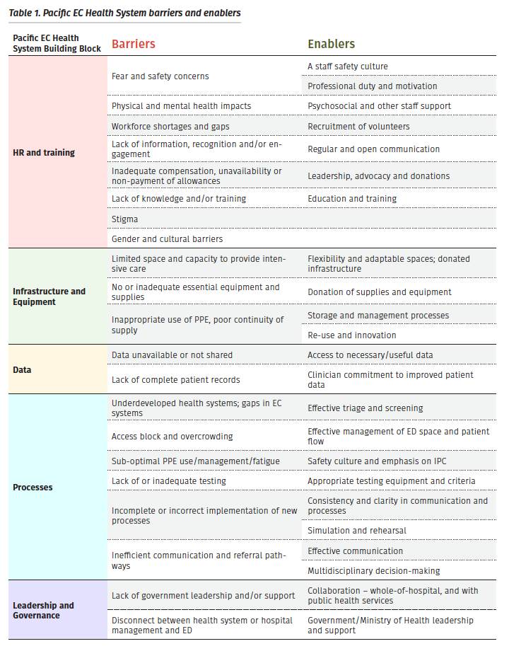

Lessons learnt
Learnings from preparations in response to COVID-19 in Indo-Pacific countries are valuable to other countries, particularly LMICs, that are adapting and need low-cost strategies to overcome clinical, ethical and limited-resource challenges.

In the forums and interviews participants told many stories of resourcefulness and local innovation. These ranged from HCWs and community members making face masks, and pharmacists creating salbutamol spacers from plastic bottles, to the use of plastic-covered metal screens to reconfigure the emergency department into distinct spaces and repurposing a major sporting facility for use as an isolation centre.

The key learnings we identified in relation to each of the Pacific EC Health System Building Blocks are presented in Table 2.

Recommendations

Collectively our findings informed the development of recommendations to improve EC preparedness and responses to future pandemics. These are detailed in the report, and include recommendations to PIC governments and health services to:
- prioritise the provision of personal protective equipment (PPE) for frontline HCWs and support the mental health and wellbeing of staff, especially EC clinicians who are at high risk of burnout and compassion fatigue
- include frontline EC clinicians in task forces and working groups focussed on the clinical components of public health emergencies
- ensure essential services and routine care are maintained, to minimise unintended consequences of responding to public health emergencies
- apply lessons learned through the COVID-19 pandemic to ongoing efforts to strengthen health systems and EC.

Next steps

Coronavirus has spread to about half of all PICs. Some PICs have reported no community transmission; others are grappling with large numbers of cases. As the pandemic continues it is vitally important to share experiences and learnings.

The ACEM and SPC research team has completed a second phase of data collection through focus groups and additional in-depth interviews with clinicians in the Pacific region (March to July 2021), and analysed that data to add to our earlier findings.

We are preparing a series of journal papers to ensure the research findings, lessons learnt and recommendations for improving preparedness for the ongoing pandemic and for future public health emergencies are shared both across the Pacific region and globally.

Table 2: Lessons learnt

HR and  training | - Moving from fear and panic to confidence and readiness to respond to public health emergencies was enabled by clear and open communication, education, training (including simulations), leadership and peer support.
- HCWs need to feel safe, engaged, valued and protected to overcome fear and reluctance to participate in the public health emergency response.
‘The staff, I think, are potentially one of our biggest problems. They’re really unhappy. They’re frightened. They haven’t been engaged with.’
- Some HCWs will remain resistant and unwilling to work at the frontline; rather than force them to engage in training, it was more effective to focus on protecting and supporting the HCWs who were willing to work in COVID-19 areas.
- Proactive and transparent information-sharing was necessary to empower and engage staff, and dispel COVID-19 myths.
- Securing staff entitlements including appropriate remuneration, risk allowances, income protection and insurance agreements, mental health care, and appropriate accommodation and support for staff quarantine required clinician leadership and advocacy.
‘The staff, we love our job but, we have issues like with our leaders and our salaries and all this. They’re trying to minimise our overtime, which is going to be very hard for us, because when the real crisis will come we will still need to, we will go beyond whatever they limit us to make. But ... the nurses are still complying with our schedule.’
- Continuing education and training was, and will be, necessary to maintain staff safety, reduce the risk of burnout or complacency, and ensure preparedness for future public health emergencies.
Infrastructure  and Equipment | - It was most effective – and safer for staff and patients – to “do the basics well” and not be pressured to implement interventions until there were clear guidelines and staff were trained and comfortable.  ‘In terms of intensive care, I don’t think we’ll be able to do that here. We don’t have ventilators, we don’t have a lot of stuff here.’
- The availability and appropriate use of PPE was key to staff safety (actual and perceived) in managing patients with infectious disease – and required adequate supply, training and support, and ongoing monitoring of practices (donning, wearing and doffing) for all workers.
‘We do have major issue with low PPE supplies due to closed borders. We have ordered PPE and some donations [are] on the way. However, still trying to get them into the country by boat … as flights are still closed.”
- Proper implementation of screening, IPC and diagnostic processes was essential to protect staff (and other patients) from undifferentiated patients presenting at the ED. Having enough space and good design with infrastructure was crucial.
- Having infectious disease screening and isolation facilities separate from the ED prevented further impacts on ED operations
‘Our facilities were not ready, in terms of preparation … we’ve decided that we will handle our COVID patients somewhere outside of the hospital.’
Processes  and Data | - An emergency response plan, clinical guidelines and SOPs are necessary, ideally prepared in advance and country-specific, and need to be properly implemented.  ‘Before they send a case or refer a case whoever is referring will update the ED first, “Look we are sending this case over to you guys and this is what we (referral hospital) have done”. Actually, we don’t have these things as a national guideline. I have created one because at the end of the day the burden comes to us.’
- A whole health system approach and planning is essential, including public health, pre-hospital, ED and inpatient teams. A well-functioning pre-hospital system is necessary to maintain patient care during public health emergencies.
- Settings with more robust emergency care systems were better placed to respond to the pandemic and scale-up their capacity for triage, risk assessment and clinical management. There was an intrinsic link between ‘routine care’ capability and preparedness for public health emergencies.
‘Before COVID we didn’t have any sort of patient flow system if you work here; so it’s like any Tom, Dick and Harry will just come in.’
- Effective IPC precautions (to protect staff and patients), screening processes (to determine transmission risk) and triage systems (to identify urgency and care needs) were key to a safe and effective response to a communicable disease outbreak. It was acknowledged that these processes should be used not only during the COVID-19 pandemic but in routine practice.
- Adequate testing capacity and appropriate testing criteria were necessary to ensure staff safety as well as sustainability long term.
‘That’s the drawback of the system – we’re not actually initiating any responses until we get a positive case. But we won’t know we’ve got a positive case until we’ve tested, and then we’re already looking after them.’
Leadership and  Governance | - Involvement of ED clinicians in response planning and national taskforces helped ensure the incorporation of EC processes and recognition of the burden on EDs at the frontline of the response.  ‘The emergency staff are leading transport. They’re on all the care committees. They’re on the national committee. And they’re actually the people putting forward good evidence-based care. And trying to override political decisions, as opposed to health science decisions.’
- A whole-of-hospital response, along with effective and interdepartmental collaboration and communication, is crucial – and was achievable if the hospital executive demonstrated leadership and engaged all departments.
- Sharing evidence, experiences, strategies (what worked, what didn’t) and resources with colleagues across the region provided peer support, encouragement and ideas.
‘Whenever we’re not sure about anything, and we call up any of the emergency physicians and we ask what is being done, and they send us papers about it and have offered advice that has been like a lifeline for us here.’
- Many of the clinical and ethical challenges experienced during the pandemic were not unique to COVID-19, and reflected the experiences of clinicians who have responded to other public health emergencies (such as measles outbreaks).
- Expert partner organisations are a critical support to aid evidence-informed policy and practice, and to provide technical assistance where local capacity is limited.

The full report

You can read or download the full report ‘The Ethics of Public Health Emergency Preparedness and Response: Experiences and lessons learnt from frontline clinicians in low- and middle-income countries in the Indo-Pacific region during the COVID-19 pandemic’ at: https://acem.org.au/getmedia/b3f78c65-8841-46eb-993b-bbc10dd37594/WHO-Report-R10

Acknowledgements

The ACEM GECCo and SPC research team is grateful to those frontline care providers from across the Indo-Pacific Region who generously provided input, including Dr Vincent Atua (Vanuatu), Dr Gustodio Alves de Jesus (Timor-Leste), Sr Helen Murdoch (Kiribati), Dr Gary Nou (Papua New Guinea), Dr Penisimani Poloniati (Tonga), Dr Trina Sale (Solomon Islands) and Mr Mamatuki Sosefo (Fiji). We also thank all the participants of ACEM GEC’s COVID-19 Online Support Forums who openly shared their experiences and learnings with their colleagues in the Pacific region and with the research team.

The report is part of an Epidemic Ethics/WHO initiative which has been supported by FCDO/Wellcome Grant 214711/Z/18/Z. Co-funding for this research was received from ACEM Foundation via an International Development Fund Grant awarded to Principal Investigator Dr Megan Cox.

Contacts

For more information about this project:
Megan Cox Sarah Körver
Project lead and principal investigator Manager, Global Emergency Care
megan.cox@sydney.edu.au sarah.korver@acem.org.au
Australasian College for Emergency Medicine
Global Emergency Care Desk
gec.network@acem.org.au
acem.org.au
+61 3 9320 0444

Phillips G, Creaton A, Airdhill-Enosa P, Toito’ona P, Kafoa B, O’Reilly G, et al. Emergency care status, priorities and standards for the Pacific region: A multiphase survey and consensus process across 17 different Pacific Island Countries and Territories. The Lancet Regional Health – Western Pacific. 2020;1:100002.

